Sprinkle’s Magic Labyrinth - Design Specification
Software Engineering
Luke MacLean, Colin Crowe, Eddie G

Table of Contents

Scope…………………………………………………………………………...3
- System Objectives……………………………………………………….3
- Major Software Requirements………………………………………….3
- Design Constrains and Limitations……………………………………...4
Data Design…………………………………………………………………….5
- Data Objects and Resultant Data Structures…………………………….5
- File and Database Structures…………………………………………….6
  - ER Diagram……………………………………………………….6
Architecture Design……………………………………………………………7
- Review of data…………………………………………………………....7
- Derived program structure……………………………..............................8
  - Activity Diagram………………………………………………….8
  - Sequence Diagram………………………………………………....9
  - State Diagram…………………………………………………….11
  - Class Diagram…………………………………………………….12
  - Use Case Diagram………………………………………………....13
Interface Design………………………………………………………………...14
- Human-machine Interface Specification………………………………….14
- Human-machine Interface Design Rules………………………………….15
- External Interface Design Rules………………………...............................16
- Internal Interface Design Rules……………………………………………16

Procedural Design……………………………………………………………….17
- Module Descriptions……………………………………………………....17
  - DJ Login…………………………………………………………....17
  - QR Code……………………………………………………………18
  - Voter Like or Dislike Button….…………………………………...19
  - Voter Survey……………………………………………………….21
  - Voter Song Request………………………………………………...25
  - Song Request Data…….…………………………………………...26
  - Chart Data………………………………………………………….28
  - Chart Update……………………………………………………….30
Appendix…………………………………………………………………………33

Scope
- System Objectives
The objective for developing Sprinkle’s Magic Labyrinth is to provide entertainment. The game will include a pause menu where the user can save their current progress, as well as view stats. Also included will be a start menu where the use can choose to resume a game or start a new one.
- Major Software Requirements
The major requirements for the game include a computer capable of running programs developed in C#. Save states and user stats will be stores within the file directory that the game is located in. The save states will be retrieved by the game. This will occur when the use selects “Load Game” from the start menu.

- Design Constraints and Limitations
  - Time is a limiting factor in the amount of detail that can be implemented, extra levels, weapons, characters etc. are all effected by the due date.
  - The Team of developers has very little experience with the Unity3D development environment
Data Design
- Data Objects and Resultant Structures

Data Object | Result
DJ Sign-Up | User account created
DJ Login | Webpage is made accessible to DJ
PartyCode | Webpage is made accessible to voter
Survey | Launches questionnaire that collects users input and then stores it in the database
Song Request | Text-bar that will take user input and will then store it in the database
Charts | Collect data from database to create a chart for each user input category

- File and Database Structures
    - Database Structure - ER Diagram

a
1
b
c
1
1
1
d

DJ-Website
DJ-Users
DJ-Statistics
Users-Statistics
Website-Statistics
e
1

- The ER diagram above depicts the database that will be used in the website. The diagram shows the files, relationships, cardinality and fields that will be used in our database.

Architectural Design
- Review of Data and Control Flow
  - Incoming Data
    - DJ SignUp- creating a DJ user account
    - DJ Login- username and password are used to personal the webpage for each individual DJ
    - Survey and Song Resquest- information gathered from the user about the types of music that they would like to here
  - Outgoing Data (Diaplayed on the website)
    - Statistical Chart/ List update – where the information from the survey and song request will be loaded into chart or form. This is to provide easy readability for the DJ
    - QR Code Generator- the generator will develop a printable code that will be used to direct the voters to the website.

- Derived Program Structure
  - Activity Diagram
-how the program’s objects are connected through the activity that will be performed by the user.

  - Class Diagram
The class diagram shows the attributes and operations for each class that will be used in our program. The relationships between the classes are also depicted in the diagram below.

  - Sequence Diagram-displays the order and timing of events

    - DJ Diagram shows the order and timing of events that occur, from the DJ’s perspective.

    - Voter Diagram displays the order and timing of events as a voter would see them.

  - State Diagram
The state diagram is showing the login behavior that will take place whenever a user logs on to the website.
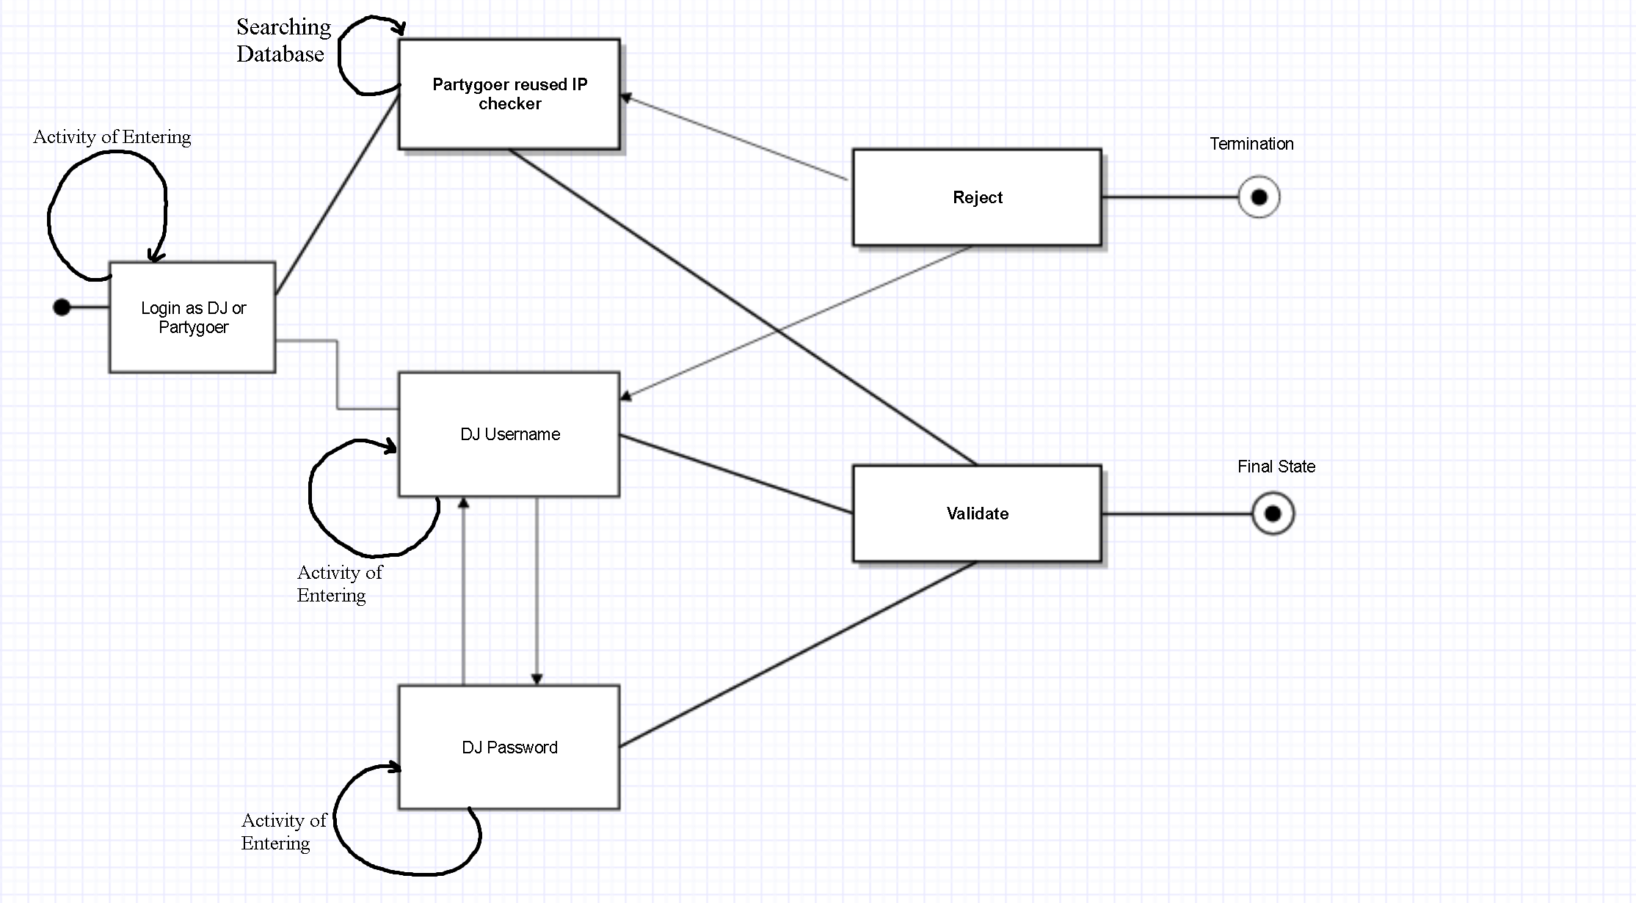

  - Use Case Diagram-
Shows how users and system will interact

Interface Design
- Human-machine Interface Specification
  - The website will consist of two pages: DJ Page and Voter Page
  - DJ Page will display:
    - Login - DJ will sign in to the website using his username and password
    - “Generate QR Code” button- creates a QR code for the DJ to display at the event. This code will then allow the attendees of the event to easily log on to the website, using a QR Scanner.
    - Statistical Data-A chart or listing will be displayed for each category that the voters respond to in the survey, song request or any other feedback options available to the voter.
  - Voter Page will display:
    - Login- user will enter their party code
    - Survey link- The link will direct the voter to the survey where they will be able to specify their taste in music.
    - Song Request- The voter will be able to submit a song request through a text form. In this form the voter will type a song of their choice and will then click submit.
    - Like/Dislike Button-The voter will be able to select whether or not they “like” or “dislike” the music that is being played by the DJ.

- Human-machine Interface Design Rules
  - The user will access the website via QR code or URL link, where they will have to choose to log in as a partygoer or DJ. Assuming the majority, accessing the site are partygoer for simplicity a fairly large button will be towards the middle of the web page asking for a party code. Also, a smaller button towards the top of the web page will provide the option to log in as DJ. For the partygoer, they will be asked their age range, favorite genre, and hometown. Only one question is displayed at a time to keep a simple theme. After the short survey, the partygoer dashboard web page will be displayed, which consist of a graph of party statistics, a dislike option and recommend songs entry limited to DJ preference.
For the DJ, users will be asked to provide a username and password, if valid the DJ dashboard web page will be displayed. At the DJ dashboard, users will have the option to create a new party, then set a recommendation limit for partygoers, then a random party code will be generated. DJ can also view their party statistics and list of recommended songs on the dashboard.

- External Interface Design
  - Interfaces to external systems or devices
The website will be able to be accessed by both mobile and desktop devices. The website will be able to be accessed through any web browser of the user’s preference; as long as the user has a reliable internet connection.
- Internal Interface Design Rules
The website database will be used to store information from both the DJ and the voter. The database will be used to store the user account information of the DJ as well as the party code that will be connected with the DJ’s information. This will take place when the DJ creates an account on our website, the information collected (i.e. username, password, party code) will then be stored for future reference. Once the DJ or voter has entered their credentials, they will then be checked to ensure that the user does already exist in our database. Data will also be collected from the voter once they have submitted their survey responses and song request information. The information from the survey and song requests will then be stored in the database in order to create the statistical charts and lists, which will be displayed on the DJ’s page.
Procedural Design
- Module Descriptions
  - DJ Login
    - Abstract
A login portal that will validate or declined username and password fields inputted by website users. The portal will search a user database for matching variables.
    - Implementation
User will input a case-sensitive username and password, then click login to start a search algorithm that will be used to search through an array of usernames and passwords. If a match is found, then user will be transported to their dashboard homepage. Else if no match is found then the user will be returned to login portal.
    - Exports
DJ dashboard/main page.
    - Imports
Username and password field.
    - Pre Conditions
Invalidate user no DJ dashboard access permissions.
    - Post Conditions
Validate user with DJ dashboard access permissions.
    - Error Handling
Always push back to homepage if error occurs.
    - Side Effects
There are no known side effects

  - QR Code
    - Abstract
Generate a specific QR code to access a unique party link within the site.
    - Implementation
User will utilize any third party QR scanner app to scan the unique QR party code which will direct users to partygoer’s dashboard.

    - Exports
Partygoer’s dashboard/main page.
    - Imports
URL link
    - Pre -Condition
Homepage Screen
    - Post Condition
Validate link directs to party goer’s dashboard.
    - Error Handling
Push to home screen if QR code link is unknown or expired.
    - Side Effects
There are no known side effects
  - Voter Like or Dislike Button
    - Abstract
The purpose for the like and dislike button is to allow the user to express whether or not they like the music that is being played by the DJ
    - Implementation
A like and dislike button will be displayed on the voter’s page
    - Exports
The input from the user (whether they click like or dislike) will then be sent to the data base and will eventually be formed into a chart
    - Input
The “like” and “dislike” button that will be displayed on the voter’s page
    - Output
If the “like” button is clicked by the voter, then one vote for “like” will be added to the data stored in the database. The same principle applies to the dislike button.
    - Subparts
The information gathered from this module will be stored in the data base
    - Error Handling
If the button that the user clicks does not highlight, then the user should assume that their answer was not submitted. The user would then re-click the “like or dislike” button.
    - Side Effects
If the “Like or Dislike button is not clicked, then the chart for user satisfaction will not be updated.
  - Voter Survey
    - Abstract:
The purpose of the survey is to gather information from the individuals (party goer) who are in the party. The party goer will answer two multiple choice questions and two short-answer questions. The information gathered will be added to a database that the DJ will view in the form of a chart. The answers will be shown in a form of statistics.
    - Implementation:
We will be using a form created will Ruby on Rails. The form will have four questions:
-What age group do you belong to?
-Where are you from?
- Which music genre do you like?
- What song would you like to recommend?
The user will then submit their answers, which will then be transported to the SQL database.
    - Exports:
The answers to each question will be exported to the SQL database
    - Imports:
Checks cache to see if user has taken the survey before.
    - Pre Conditions:
The survey will be check to see if the user has already taken the survey. If they have only the song recommendations question will appear. If they have not all of the question will appear.
    - Post Conditions:
The survey will store data saying they that the user has taken the survey. This will allow the user to skip over the first three questions of the survey and only answer the song recommendations questions.
    - Input:
-Question one is a multiple choice answer. There are three answers to choose from: What age group do you belong to? ⎔ 18-25 ⎔25-30 ⎔30+
-Where are you from? This answer will be a short text answer that the user will type in. We will require the user to enter in the format of City, State. There will be a default text that say <City, State>
-Which music genre do you like? ⎔ Hip-Hop ⎔Pop ⎔Rock ⎔ Country ⎔Techno
- What song would you like to recommend? This answer will be a short text answer that the user will type in. To make gathering data easier we will make the user enter in the name of the song and the artist/artists. <Song name, artist>
    - Output:
The answers for the multiple choice will be output to a chart the will display each answer. The text submissions will be sent to each respective category. City and state will be one category, artist will be another one, and song will be another one.
    - Subparts:
We will have a feature that will collect the data from each survey. This feature will be able to gather answers from each survey and store that data. There will also be a subpart the will know if the user has taking the survey before.
    - Error Handling
When user enters their text submissions they must enter it with the commas. If not an error message will appear with the proper way they should answer the question. A placeholder is in every text field with how the user should enter their answer. Case is not sensitive so it does not matter if there are uppercase or lowercase letters
    - Side Effects
The chart is dependent on this data
  - Voter Song Request
    - Abstract
The voter will have the option to submit the name of a song that they would like to hear the DJ play.
- Implementation
The voter’s request will be typed into a form or textbox that will be displayed on the voter’s page
- Exports
The input (song name) from the user will then be sent to the data from voter request module
- Pre Conditions
Prior to exporting the data, the user must enter a song request
- Post Conditions
The song name that was submitted by the voter will then be sent to the data from voter request module once the user has clicked submit
- Input
The name of the song that the voter would like to request
- Output
There is no output for this module
- Subparts
The data collected from the user’s request will be stored in a database until needed
- Error Handling
If there is a problem submitting a request the user will be prompted to re-enter their song request
- Side Effects
There are no known side effect for this module

  - Data from Song Request
    - Abstract
This module will collect the user’s input from the voter song request
    - Implementation
The song requests will be displayed on the DJ’s page in a list format
    - Imports
The song’s name will be imported from the voter song request module to the database
    - Pre-Condition
The user must type and submit a song request prior to importing the dong request data
    - Post Condition
Once the song request has been imported the data is then updated in the database
    - Input
The song’s name will be collected from the voter song request module
    - Output
The song’s names that have been submitted will then be formed into a list that will be displayed on the DJ’s page
    - Subparts
The voter must make a request for this module to be affective
    - Error Handling
The voter request question is a text submission. The song title and artist’s name will need to be separated by a comma, since the song title and artist’s name will each go to a separate section in data storage. If a comma is not used, an error message will display, prompting the user to please separate the song title and artist’s name with a comma. Also, this text submission is not case-sensitive.
    - Side Effects
If the user inputs a song title and/or an artist’s name that is not valid, the DJ can simply ignore it.

  - Chart Data
    - Abstract:
A visual representation of all the voters answers. The chart is live and constantly changes to stay up to date with the crowd votes. The purpose of the chart is to display information to the DJ so he can adjust the music he's playing accordingly.
    - Implementation:
User answers from the Voter survey and “Like/Dislike button will be stored in a SQL database. The answers will be shown in a Google Chart Column Chart. Example, X% of current party users are in age group 18-25. The chart will display the age groups, songs titles, artists, favorite genre, city, state and the satisfaction of the crowd. All in percentage forms.
    - Exports:
The chart columns will be exported to the Chart Update Module.
    - Imports:
The exports from the Chat Update and the Data for Survey and “Like/Dislike” Button
    - Pre Conditions:
There must be data in the Data from Survey and “Like/Dislike” Module
    - Post Conditions:
The current chart is exported so that it can be updated will more surveys and user satisfaction information
    - Output
A column on the column chart representing an answer; using percentages.
    - Subparts
Google Visual Charts
    - Side Effects
The DJ will be able to have an understanding of how much the crowd is enjoying the music. The data will be saved at the end of the party so that other DJs can have a feel for what type of music each age group, city, and state likes.
  - Chart Update
    - Abstract
Updates the charts with new data
    - Implementation
Once the data from the survey (a form) or “like/dislike” button is gathered it will then be stored in the database. The database then adds the new data to the chart. Each different answer is counted and divided by the total answers to find the percent for each answer from the user. The chart is constantly being updated as new users fill out the survey or press the “like/dislike” button. The multiple choice questions from the survey will be tallied up. The text question will be divided up by word. The like/dislike button will be counted as one vote for either like or dislike. Lastly, all of the City’s will be added to the chart, the same will be done for the States, Song titles, and artists.
Survey Example, if two people out of 10, type in Baltimore for city, Maryland for state for question 2 then the chart update module will export 20% for the user from Baltimore and 20% for Maryland.

    - Exports
The new chart that shows the new data from incoming surveys and user satisfaction from the “like/dislike” button
    - Imports
Data from the surveys and “like/dislike button”
    - Pre Conditions
There must be new surveys to pull new data from or more users utilizing the like/ dislike button
    - Post Conditions
The new data will be included into the in the data that will be added to the Column Chart.
    - Input
Data from survey and “like/ dislike” button
    - Output
New Percentages
    - Subparts
There are no subparts for this module
    - Error Handling
There are no known errors at this time
    - Side Effects
The chart will be able to stay up to date. The DJ plays music that can last for hours so the chart music be able to handle data coming in for hours. Chat Update is the loop that keeps the charts current.

Appendix
- Project Programming Language
  - The website project was originally designed to use the Ruby programming language along with the Ruby on Rails framework. Although, the developers of the website no longer feel that Ruby and Ruby on Rails are best suited for the project. In result, the website will be developed using the HyperText Markup Language (HTML).

